Library Management System – Integration test execution details
1. Book Management
1.1 Create Book – Success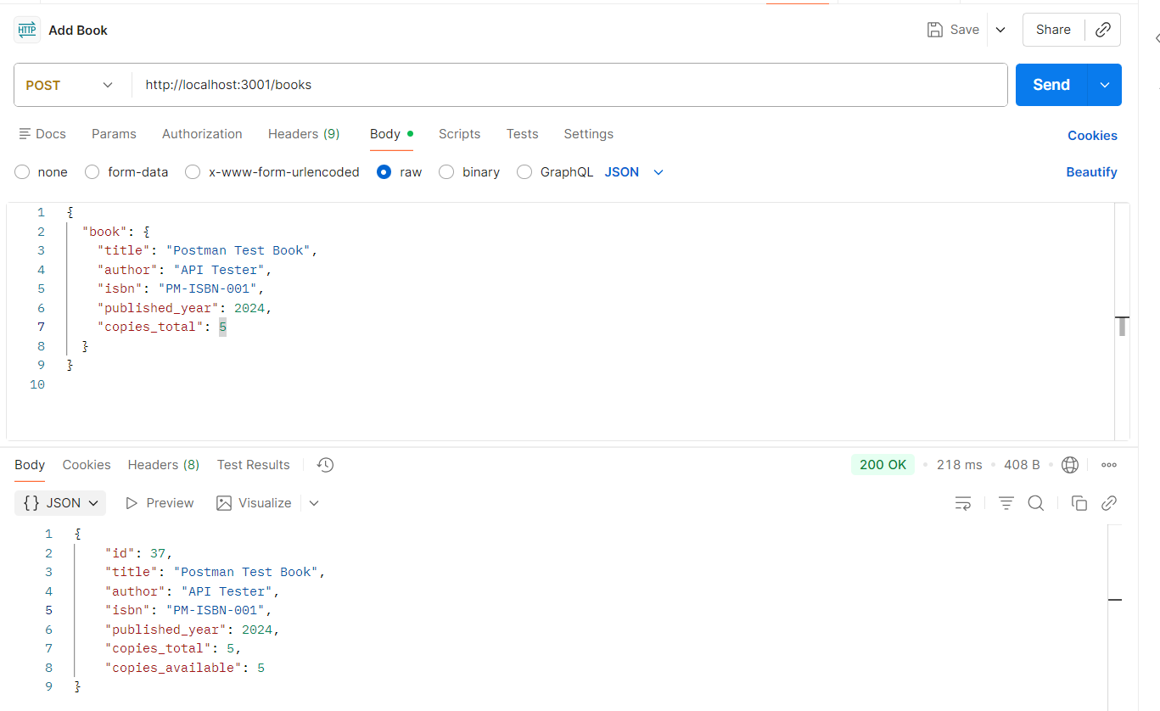

1.2 Create Book – Validation Failure Scenario (Negative scenario)

